Kentucky Prescribed Fire Council
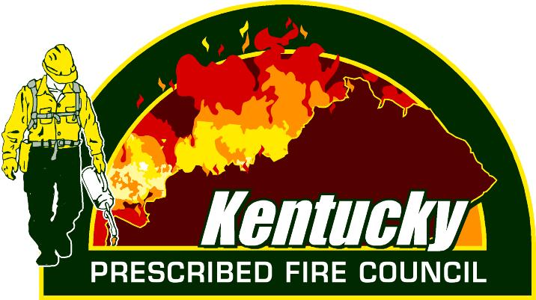
2024 Annual Meeting
Technology Future in RX

JUNE 11-12, 2024
Barren River Lake State Resort Park
1149 State Park Road, Lucas, KY 42156

JUNE 11th
11:30-11:35 Welcome (no lunch provided)
11:35-12:00 Introduction
12:00-1:15 Agency Partner Updates (KDF, OKNP, KDFWR, USFS-DBNF, TNC, USFW, and others)
1:15-1:30 Break
1:30-2:00 Applying Ecozone Models for Informed Management Action – Jake Royse, DBNF
2:00-2:15 Break
2:15-2:45 EPA/Smoke Update – Kessley Baker, KDF and Jennifer Miller, KY DAQ
2:45-3:00 Break
3:00-4:15 New Kentucky RX Notification/Database – M. Sweat and J. Moore, Technosylva
4:15-5:00 KPFC Board Updates (Field Trips, 8 hr. course, Learn & Burn, Membership Cards, Board Nominations/Recruitment)
5:00-6:00 Committee Meetings (Air Quality, Information & Education, Partnership Development, and Training)
6:00-7:30 Dinner on your own
7:30-9:00 Social/Networking

JUNE 12th - RX Technology Café
The RX Technology Café: A Platform for Professional Growth and Learning. This is your chance to network and see other technology/equipment used by different agencies in the prescribed fire field.
0830-1200
- Mapping
  - Field Maps, Avenza, Fire Mapping Assistance, and fiResponse
- RX Equipment
  - UTV with Skid, Green Dragon, Very-pistol, Drones, and etc.
- SimTable

